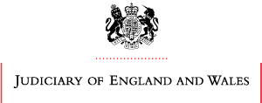 SAVE THE DATE

Local Family Justice Board in Partnership with Salford University

ANNUAL CONFERENCE
WEDNESDAY 15TH FEBRUARY 2017

The Lady Hale Building, University of Salford, Peel Park Campus
Follow us on Twitter @GMFCF
Or visit www.gmfcf.org
http://www.bing.com/search?q=GMFCF&src=IE-SearchBox - #

